**Introducing DHTML**

**Abstract**

*This article defines DHTML and discusses it in terms of its constituents – HTML 4.0, scripting languages, the Document Object Model (DOM), and Cascading Style Sheets (CSS). It explains how DHTML events and event handlers operate within the DOM and discusses the advantages and disadvantages of this browser enhancement feature.*

**Introduction**

Dynamic Hypertext Markup Language, otherwise known as DHTML, can be defined as the collection of built-in browser features that enable you to create animated and user-interactive web pages. The browser can alter these web pages while they are being displayed, thereby making them all the more dynamic. Although many of the DHTML foundations are specified in HTML, DHTML has its own set of features that further enhance interactivity.

**What features constitute DHTML?**

DHTML is not a markup language but rather a browser enhancement feature. It is the collective term for a combination of technologies consisting of HTML 4.0, a scripting language (JavaScript or VBScript, for example), the Document Object Model (DOM), and Cascading Style Sheets (CSS). When brought together, these technologies can help a web developer bring a web page to life.

**Scripting languages**

Scripting languages enable programmers to design a response to a user event – for example, processing forms, creating floating windows or moving the mouse. The DHTML Document Object Model uses JavaScript or VBScript to increase the dynamic interaction between the user and a web page.

**Document Object Model**

The DOM is effectively the core of DHTML, as it is the DOM that actually makes HTML modifiable. The DOM is a hierarchy of elements that are present in the browser at any one time, and includes information such as window and browser properties and HTML elements. It makes all the objects in an HTML or XML page accessible to scripting languages. Among the objects that this interface stores are images, forms, CSS properties, and frames. JavaScript or VBScript manipulate these to create more dynamic web pages. If programmers wish to change or update the style, content, or structure of a document, they can do so before, during, or after the loading of a web page.

Although Netscape introduced the DOM concept for Navigator 2.0 in 1995, primary development of the DOM has taken place on Microsoft's Internet Explorer. Because the two browsers progressed at different rates, the World Wide Web Consortium (W3C) aimed to create a standard platform-neutral and language-neutral application programming interface (API) that is more widely accepted across browsers and servers and that will operate within existing HTML, scripting languages, and style sheets. DOM Level 3 was published in 2004, and much of it is now supported by both major browsers Internet Explorer and Mozilla Firefox.

**Cascading Style Sheets**

Cascading Style Sheets provide designers with greater control over the stylistic content of their web pages. With CSS tag properties, designers can create text effects of their own and position elements on the web page with precision. Because the Cascading Style Sheets mechanism is part of the DOM, CSS properties are accessible to scripting languages, making it possible to alter the style characteristics of a web page, such as fonts, colors, positions, and margins, without altering the structure. There are currently two CSS levels – CSS1 and CSS2. Both are described as recommendations of the World Wide Web Consortium (W3C).

**DHTML events and event handlers**

DHTML events refer to actions that occur on a HTML page with or without user intervention. These can be as simple as moving the mouse over an element (mouseover event), loading a page (load event), and submitting a form (submit event). Other common events include mouse clicks and resizing the browser window.

Once an event occurs, an event handler is triggered. This is made up of JavaScript or VBScript code, which is placed inside HTML tags. Like events, event handlers can be interactive or non-interactive. Here is an interactive example in JavaScript:

onClick="alert('hello!')"

This means that when the user clicks on a particular area of the screen, "hello!" appears in a dialog box. An example of a non-interactive event handler would be onLoad, where the event would be the loading of the page. With this event, JavaScript code is executed automatically as the page downloads, and user intervention is not required at any point.

Because all DHTML events are part of the DOM and not JavaScript, different browsers may not support the same objects and events. However, the following are some of the objects and events that are supported in most browsers:

| **Table 1: DHTML events supported by most browsers** | | |
| --- | --- | --- |
| **Event** | **Objects** | **Event handler** |
| click | area, button, checkbox, link, radio, reset, submit | onClick |
| mouseover | area, link | onMouseOver |
| mouseout | area, link | onMouseOut |
| select | password, text, textarea | onSelect |
| submit | Form | onSubmit |
| focus | password, select, text, textarea, window | onFocus |
| change | select, text, textarea | onChange |
| load | image, window | onLoad |
| unload | window | onUnload |

**Advantages of DHTML**

The following are some advantages of DHTML:

* Unlike Microsoft's Active Server Pages (ASP), DHTML works from the client side – it does not need to access the server every time it receives browser input
* DHTML is more interactive than HTML and has the ability to replace many functions usually performed by animated GIFs, Java applets, or ActiveX controls
* DHTML employs new methods of formatting text, positioning HTML page elements, and triggering scripting events
* DHTML is faster and uses less memory than Java

**Summary**

DHTML is a browser enhancement feature, which allows designers to create web documents that are more engaging and interactive than previous versions of HTML. It is made up of a set of technologies that includes HTML 4.0, scripting languages, Cascading Style Sheets (CSS), and the Document Object Model (DOM). By combining these technologies, more dynamic web pages can be created. Merging HTML with the scripting language enables interaction with tags. CSS provides increased control over the stylistic content of HTML elements, and the DOM, which is the core component of DHTML, makes HTML modifiable.

DHTML events and event handlers are part of the DOM. They can be interactive or non-interactive. Events, which are actions on a web page, trigger event handlers, which in turn activate code and create dynamic actions on a web document. DOM versions differ on Netscape Navigator 4.0 and Internet Explorer 4.0, and as a result, Netscape and Microsoft do not share the same set of events, nor are all page elements subject to the same events on all browsers.

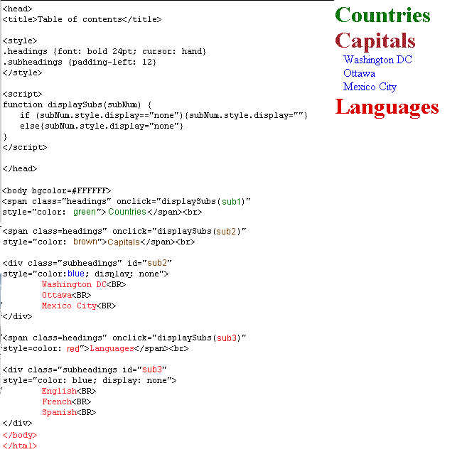

Which of the following options applies to the Document Object Model?

|  |  |  |
| --- | --- | --- |
|  | It allows the content of a web page to be updated only when that page is closed |  |
|  | It allows scriptors to access and manipulate objects in an HTML page |  |
|  | It is compatible with all browsers |  |

Bottom of Form

Top of Form

Which of the following are components of DHTML?

|  |  |  |
| --- | --- | --- |
|  | Cascading Style Sheets |  |
|  | HTML 4.0 |  |
|  | Document Object Model |  |
|  | Active Server Pages |  |
|  | JavaScript |  |

Top of Form

Let's say your creating cross-browser code and want to test support for Netscape browsers.  
  
Which of the following statements allows you to do this?

|  |  |  |
| --- | --- | --- |
|  | Document.all |  |
|  | Document.layers |  |
|  | Document |  |

Which of the following are components of DHTML?

|  |  |  |
| --- | --- | --- |
|  | Cascading Style Sheets |  |
|  | HTML 4.0 |  |
|  | Document Object Model |  |
|  | Active Server Pages |  |
|  | JavaScript |  |

Bottom of Form